1.1.4. Area of Triangle
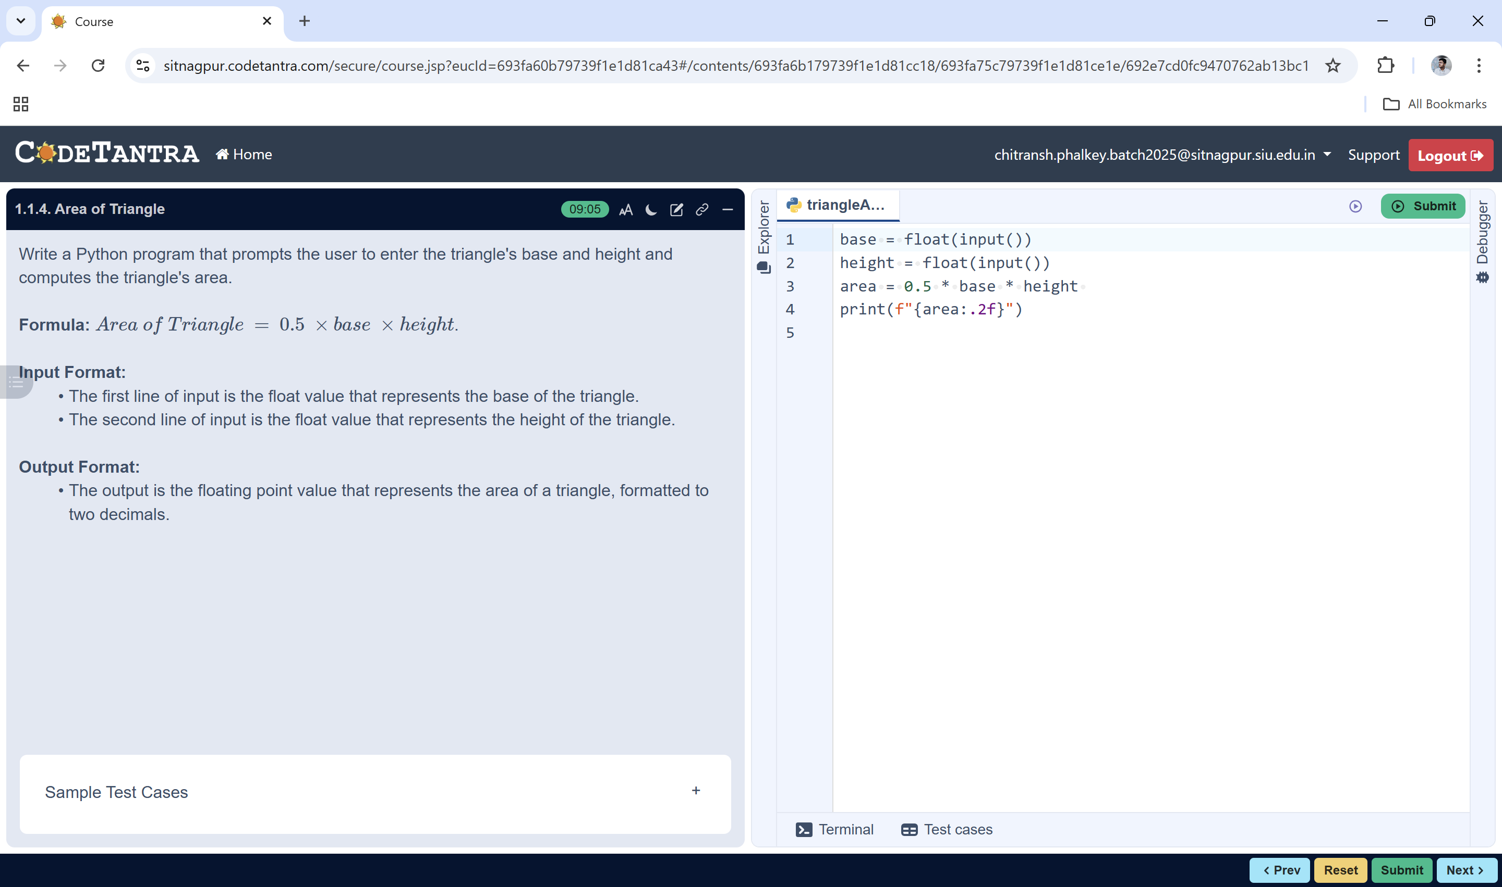
Input base, height
START
Algorithm: Area of a Triangle
area = 0.5×base×height
- Start
- Read the value of base from the user
- Read the value of height from the user
- Calculate the area using the formula:
area = 0.5 × base × height
Print area
- Display the value of area formatted to 2 decimal places
- Stop
STOP

